Details

**MongoDB**

– [C.Sunter@newcastle.ac.uk](mailto:C.Sunter@newcastle.ac.uk) Jazzcat2

* b80273436 Primeval#2007
* admin adminpassword

Intro

Tool Used & Decisions

* Docker
* Web Stack - Vue.js
* Git bash
* VsCode
* - Node.js
* Mongo Db Atlas
* Mongoose
* - Post man – testing API’s
* eslint-config-airbnb
* babel
* express
* nodeman – resarts server for you
* axios
* Currpots

Implementations

* Front End
* Back End
* CI
* Server
* Version Control

Reflection & Evaluations

Setting VS Code to use git bash for the terminal

Setting up using npm init

Add dependencies to the package.JSON file so that npm install will install them

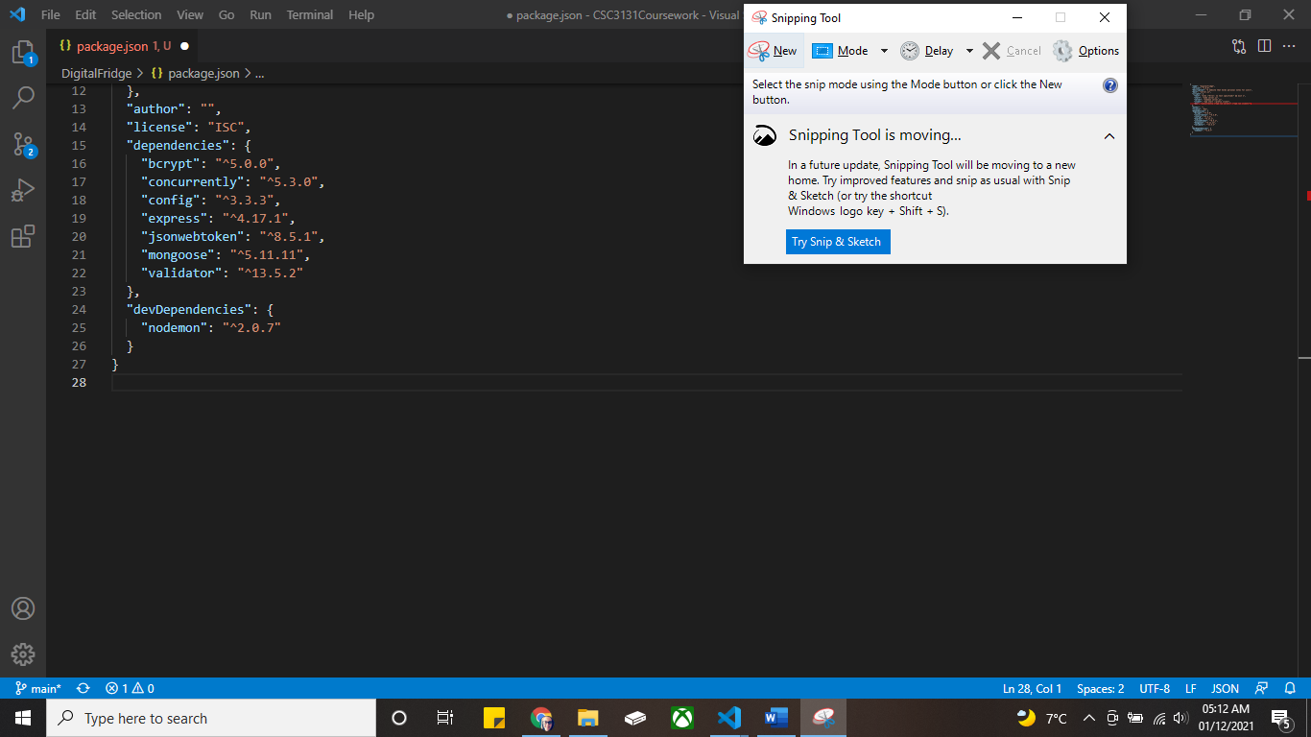

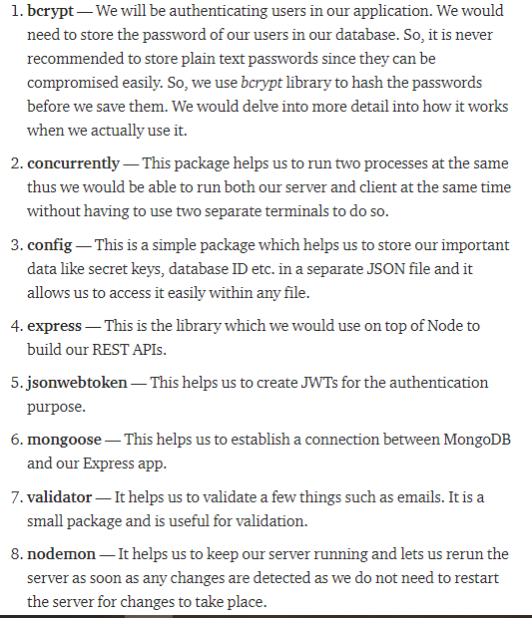

Choosing the cloud provider for mongo db

<https://www.smbnation.com/big-data-analytics/2255-5-reasons-why-azure-is-better-than-aws>

Setting VS Code to use git bash for the terminal

Installed node.js + Created vue project and file layout.

Created server.js file and tested using local host

Created MongoDB, whitelisted IP

and tried connecting to it. But got error so installed CURRpots to see what the ports were listening to. Didn’t see anything strange in the CURRPOTTS – realised that it was because I was listening twice within the code. Removed the second listen and all good

Added the auth API’s and tested them using postman

Added the beginning of the frontend. Added router, navbar, login/register forms using a mixture of bootstrap and normal css

Added the methods to the register and login components that would allow the front and back end to talk. These check for different http responses. Uses SWAL for the auth response UI

The design wasn’t looking sharp enough so changed the navigation bar and added a variables file to make it easier to apply the same styles over multiple places/components. The design of the forms also changed.

Created placeholders/template for the images using flex to allow for dynamic changes and different sized images

Created a S3 bucket to store images

